DROP DATABASE

The DROP DATABASE statement is used to drop an existing SQL database.(MSSQL_Workbench).

Syntax: DROP schema databasename;

Eg : DROP schema mssqlpractise2;
-----------------------------
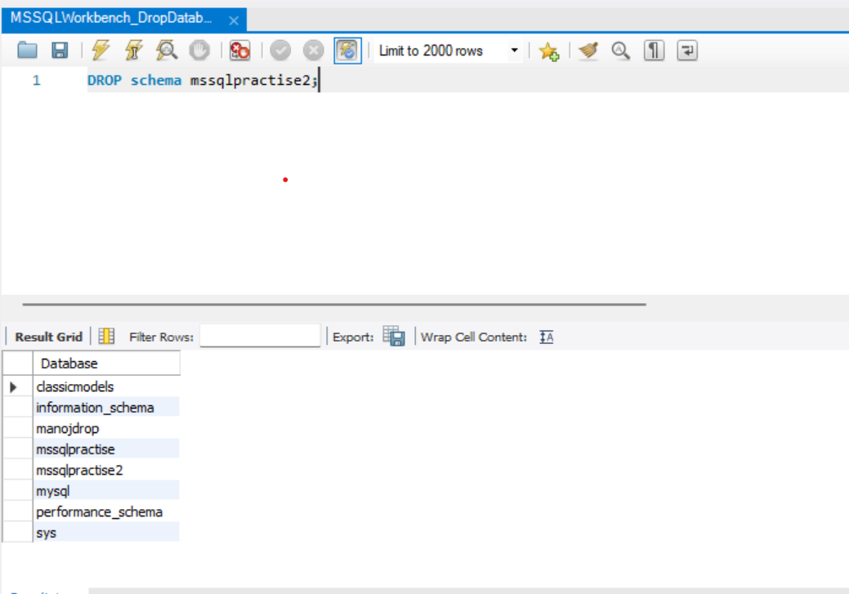

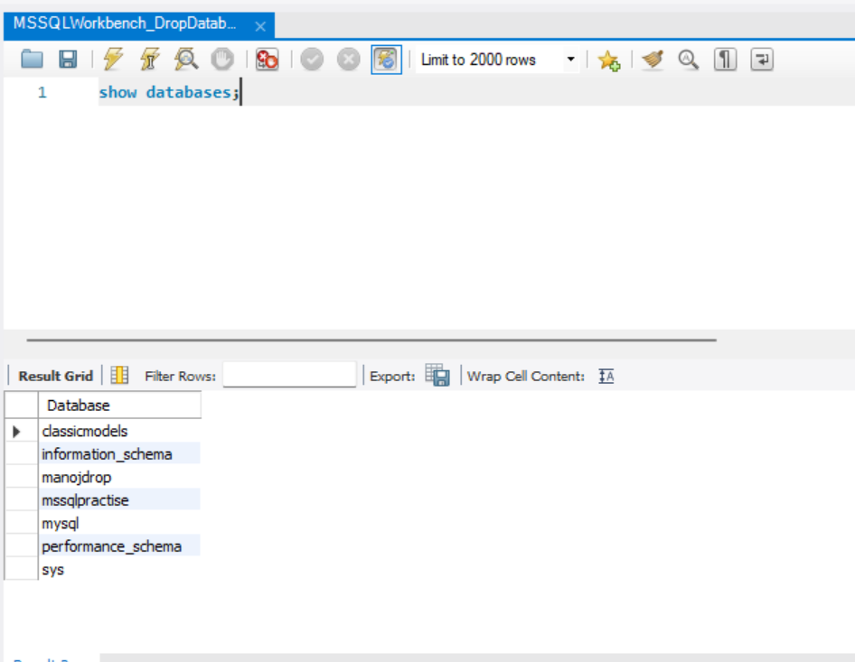

Be careful before dropping a database. Deleting a database will result in loss of complete information stored in the database.

Make sure you have admin privilege before dropping any database. Once a database is dropped, you can check it in the list of databases with the following

SQL command: SHOW DATABASES;

